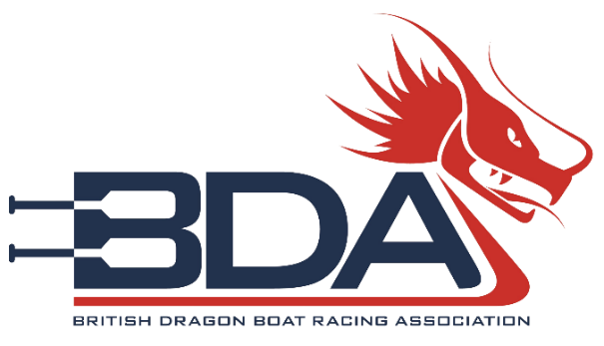

Club development fund

BDA club development fund criteria
Every year the BDA Executive Committee holds a reserve of money that BDA registered clubs can apply for to help them develop. This is known as the BDA club development fund.
The BDA club development fund can be applied for from a nominated officer if the application demonstrates that the funding will be used to help develop the club, the BDA or dragon boating in general.
The BDA Executive Committee will assess each application based on the current BDA strategy and each club applying for money will need to describe and show that the fund will be used to develop at least one of the pillars in the strategy.
A full document on the BDA strategy, with information on each pillar, is available on our website at: https://www.dragonboat.org.uk/the-bda/vision-strategy/
The five strategy pillars are:
- Grow the Sport
- Connecting Our members
- Supporting Our Clubs
- Providing competitive and innovative racing
- Participating in the International Community
It is recommended that each club applies for the development fund only once per calendar year. Only in certain circumstances will the BDA Executive Committee consider additional applications.
Clubs who have successfully received a grant from the development fund will be shown on our website with the reason for the grant and the year it was awarded.
To apply for a grant, please complete the application form on page 2 and send the completed form to treasurer@thebda.org.uk.
The BDA Executive will assess the merits of the application at the next BDA Executive Committee meeting. Meetings are typically held once per month.

BDA club development fund application form
Name of BDA club making application
Have you made an application to the Fund already? If so when?
Please describe what you want the fund to assist your club with.
Continue over the page if you need more room.

Please describe the outcomes you would expect to occur based on the allocation of these funds.
Continue over the page if you need more room.

How much funding, in pounds, are you looking for?
Name of club officer
Signature of club officer
BDA individual membership number
Position in club
Main club email address
Club officer email address

